Smart Water Fountains Using IOT

PHASE 4 Submission Document

Team member

au312821104027 : Dhanush Chakravarthy R

au312821104030 : Dowlathnisa S.B

au312821104036 : Ginni Sinha

au312821104052 : Karunamoorthy S

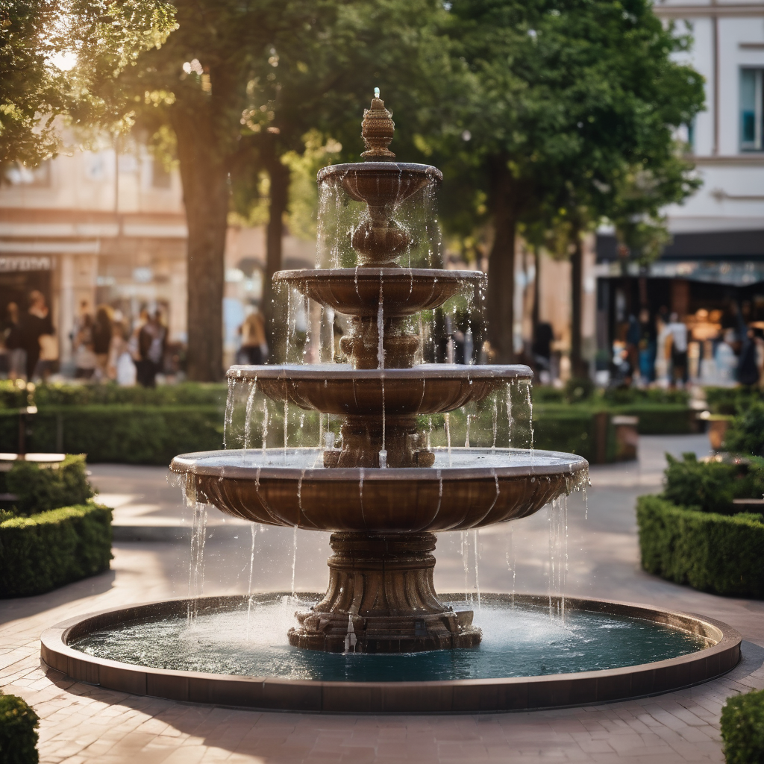

**Introduction :**

The 'Smart Water Fountains' project, a pioneering endeavor in the realm of urban infrastructure and environmental conservation. Our project takes conventional public water fountains and infuses them with IoT technology, paving the way for real-time monitoring, water efficiency, predictive maintenance, and heightened public awareness. This phase spotlights the core of our project's development phase, where we delve into the intricacies of the code that drives the IoT sensors and the water fountain status platform. This digital architecture serves as the vital link between sensor data and user interaction, underpinning our mission to revolutionize water fountain management and enhance sustainability.

**OUR DEVELOPMENT:**

* The development phase of the 'Smart Water Fountains' project is crucial in realizing our vision.
* It involves integrating IoT technology with traditional water fountains, fundamentally transforming their functionality. Central to this phase is the sophisticated code governing IoT sensors and the fountain status platform.
* This code forms the digital infrastructure, enabling seamless communication between sensors and the user interface.
* Real-time data on vital parameters is collected, analyzed, and processed, facilitating informed decision-making in water management.
* Predictive maintenance strategies are implemented to re-emptively address potential issues, ensuring optimal performance.
* The user-friendly interface allows for real-time monitoring, customization, and promotes public awareness for sustainable water usage.
* This interface provides a comprehensive view of all connected fountains, enabling users to monitor their status and performance in real-time.
* It also offers customization options, allowing users to tailor settings to their specific requirements.
* This digital architecture not only enhances water management but also fosters a culture of conservation and sustainability within urban environments.

**OUR WEBSITE CODE USING(HTML,CSS,JAVASCRIPT)**

<!DOCTYPE html>

<html>

<meta name="viewport" content="width=device-width, initial-scale=1">

<link rel="stylesheet" href="https://cdnjs.cloudflare.com/ajax/libs/font-awesome/4.7.0/css/font-awesome.min.css">

<style>

body {margin:0;}

.icon-bar {

  width: 100%;

  background-color: #555;

  overflow: auto;

}

.icon-bar a {

  float: left;

  width: 20%;

  text-align: center;

  padding: 12px 0;

  transition: all 0.3s ease;

  color: white;

  font-size: 36px;

}

.icon-bar a:hover {

  background-color: #000;

}

.active {

  background-color: #04AA6D;

}

</style>

<body>

<div class="icon-bar">

  <a class="active" href="#"><i class="fa fa-home"></i></a>

  <a href=""><i class="fa fa-search"></i></a>

  <a href=""><i class="fa fa-envelope"></i></a>

  <a href=""><i class="fa fa-globe"></i></a>

</div>

<style>

    .container {

      display: inline-block;

      cursor: pointer;

    }

    .bar1, .bar2, .bar3 {

      width: 35px;

      height: 5px;

      background-color: #333;

      margin: 6px 0;

      transition: 0.4s;

    }

    <style>

.accordion {

  background-color: #eee;

  color: #444;

  cursor: pointer;

  padding: 18px;

  width: 100%;

  border: none;

  text-align: left;

  outline: none;

  font-size: 15px;

  transition: 0.4s;

}

.active, .accordion:hover {

  background-color: #ccc;

}

.panel {

  padding: 0 18px;

  display: none;

  background-color: white;

  overflow: hidden;

}

</style>

</head>

<body>

    <style>

        * {box-sizing: border-box}

        body {font-family: "Lato", sans-serif;}

        /* Style the tab */

        .tab {

          float: left;

          border: 1px solid #ccc;

          background-color: #f1f1f1;

          width: 20%;

          height: 300px;

        }

        /* Style the buttons inside the tab */

        .tab button {

          display: block;

          background-color: inherit;

          color: black;

          padding: 22px 16px;

          width: 100%;

          border: none;

          outline: none;

          text-align: left;

          cursor: pointer;

          transition: 0.3s;

          font-size: 17px;

        }

        /* Change background color of buttons on hover */

        .tab button:hover {

          background-color: #ddd;

        }

        /* Create an active/current "tab button" class */

        .tab button.active {

          background-color: #ccc;

        }

        /* Style the tab content */

        .tabcontent {

          float:;

          padding: 0px 12px;

          border: 1px solid #ccc;

          width: 70%;

          border-left: none;

          height: 400px;

        }

        </style>

        </head>

        <body>

        <center>

        <h1>SMART WATER FOUNTAIN</h1>

        </center>

        <div class="tab">

          <button class="tablinks" onclick="openCity(event, 'FOUNTAIN 1')" id="defaultOpen">FOUNTAIN 1</button>

          <button class="tablinks" onclick="openCity(event, 'FOUNTAIN 2')">FOUNTAIN 2</button>

          <button class="tablinks" onclick="openCity(event, 'FOUNTAIN 3')">FOUNTAIN 3</button>

        </div>

        <div id="FOUNTAIN 1" class="tabcontent">

          <h3>FOUNTAIN 1</h3>

          <center>

            <h3>Water Flow:</h3>

            <h3>pressure:</h3>

            <h3>temperature</h3>

            <h3>PH Level:</h3>

          </center>

          <h2></h2>

          <style>

            * {box-sizing: border-box;}

            .container {

              position: relative;

              width: 70%;

              max-width: 200px;

            }

            .image {

              margin: 10px;

             display: flex;

             position: relative;

             top: -180px;

            }

            .overlay {

              position:relative;

              bottom: 0;

              background: rgb(0, 0, 0);

              background: rgba(0, 0, 0, 0.5); /* Black see-through */

              color: #f1f1f1;

              width: 80%;

              transition: .5s ease;

              opacity:0;

              color: white;

              font-size: 10px;

              padding: 10px;

              text-align:left;

            }

            .container:hover .overlay {

              opacity: 1;

            }

            </style>

            </head>

            <body>

            <h2></h2>

            <div class="container">

              <img src="fountain 3.jpg" alt="fountain" class="image">

            </div>

          <center>

          </center>

        </div>

        <div id="FOUNTAIN 2" class="tabcontent">

          <h3>FOUNTAIN 2</h3>

          <center>

            <h3>Water Flow:</h3>

            <h3>pressure:</h3>

            <h3>temperature</h3>

            <h3>PH Level:</h3>

          </center>

          <h2></h2>

          <style>

            * {box-sizing: border-box;}

            .container {

              position: relative;

              width: 70%;

              max-width: 200px;

            }

            .image {

              display: block;

              width: 80%;

              height:auto;

            }

            .overlay {

              position:relative;

              bottom: 0;

              background: rgb(0, 0, 0);

              background: rgba(0, 0, 0, 0.5); /* Black see-through */

              color: #f1f1f1;

              width: 80%;

              transition: .5s ease;

              opacity:0;

              color: white;

              font-size: 10px;

              padding: 10px;

              text-align:left;

            }

            .container:hover .overlay {

              opacity: 1;

            }

            </style>

            </head>

            <body>

            <h2></h2>

            <div class="container">

              <img src="fountain 2.jpg" alt="fountain" class="image">

            </div>

        </div>

        <div id="FOUNTAIN 3" class="tabcontent">

          <h3>FOUNTAIN 3</h3>

          <center>

            <h3>Water Flow:</h3>

            <h3>pressure:</h3>

            <h3>temperature</h3>

            <h3>PH Level:</h3>

          </center>

          <h2></h2>

          <style>

            * {box-sizing: border-box;}

            .container {

              position: relative;

              width: 70%;

              max-width: 200px;

            }

            .image {

              display: block;

              width: 80%;

              height:auto;

            }

            .overlay {

              position:relative;

              bottom: 0;

              background: rgb(0, 0, 0);

              background: rgba(0, 0, 0, 0.5); /* Black see-through */

              color: #f1f1f1;

              width: 80%;

              transition: .5s ease;

              opacity:0;

              color: white;

              font-size: 10px;

              padding: 10px;

              text-align:left;

            }

            .container:hover .overlay {

              opacity: 1;

            }

          </style>

            </head>

            <body>

            <h2></h2>

            <div class="container">

              <img src="Fountain 1.jpg" alt="fountain" class="image">

            </div>

        </div>

        </div>

        <script>

        function openCity(evt, cityName) {

          var i, tabcontent, tablinks;

          tabcontent = document.getElementsByClassName("tabcontent");

          for (i = 0; i < tabcontent.length; i++) {

            tabcontent[i].style.display = "none";

          }

          tablinks = document.getElementsByClassName("tablinks");

          for (i = 0; i < tablinks.length; i++) {

            tablinks[i].className = tablinks[i].className.replace(" active", "");

          }

          document.getElementById(cityName).style.display = "block";

          evt.currentTarget.className += " active";

        }

        // Get the element with id="defaultOpen" and click on it

        document.getElementById("defaultOpen").click();

        </script>

        <hr>

        <footer>

          <CENTER>

        <H1>IBM IOT POJECT</H1>

        <p>&copy; copyright @ DHANUSH CHAKRAVARTHY R</p>

        <p>Contact: 21cse19@act.edu.in <br>21cse23@act.edu.in <br> 21cse29@act.edu.in <br> 21cse46@gmail.com</p>

          </CENTER>

        </footer>

</body>

</html>

**OUTPUT:**

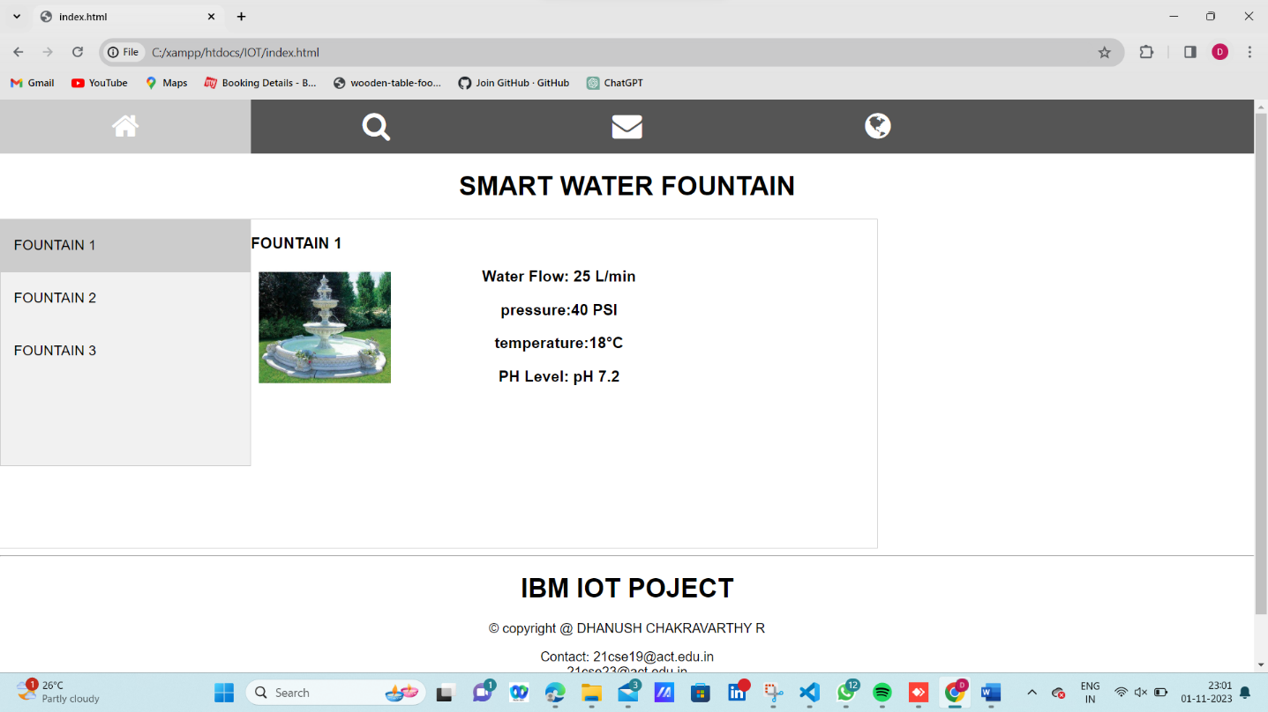

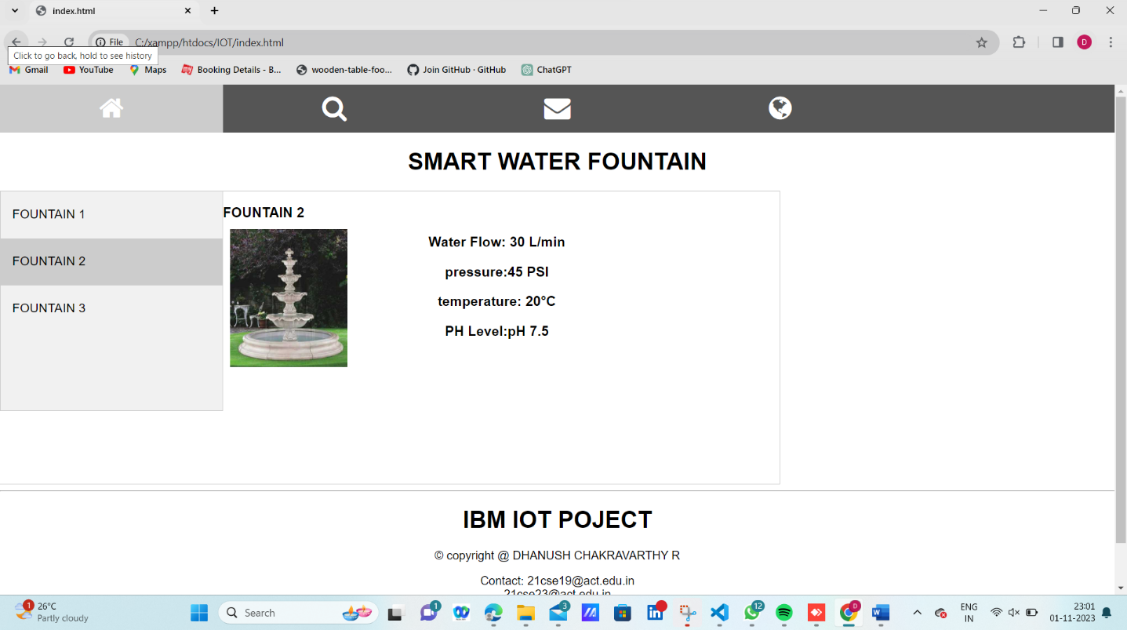

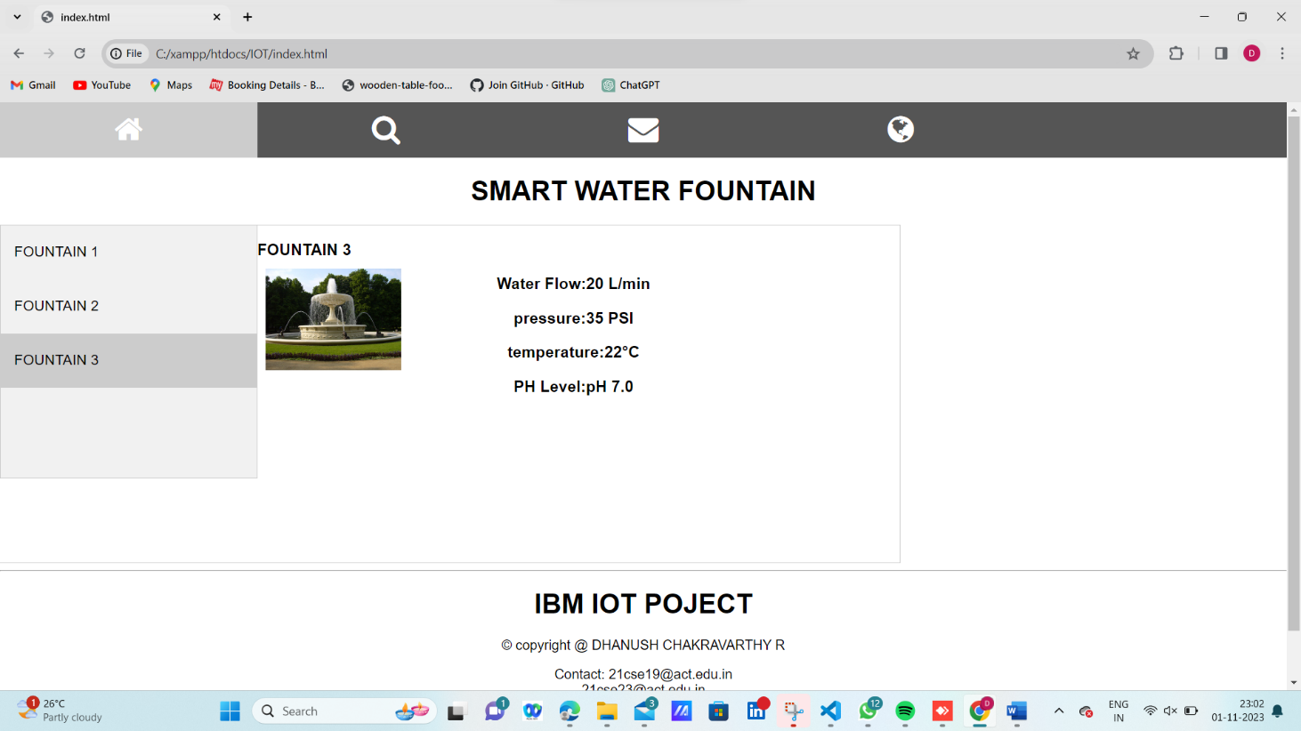

**FUTURE SCOPE :**

* Integration with smart home systems, advanced data analytics, and a dedicated mobile application are key avenues.
* Predictive maintenance, water quality alerts, and expanding sensor capabilities offer room for enhancement. Initiatives like water conservation and global deployment can amplify impact.
* User feedback, environmental monitoring, and potential commercial applications provide further opportunities.
* Certification and staying abreast of IoT trends are vital for sustained success and innovation in smart water fountain technology.

**CONCLUSION:**

* we have achieved significant success in the development of our smart water fountains, leveraging IoT technology
* we have successfully created our own website using HTML, CSS, and JavaScript. The website showcases three sample fountains, but it is adaptable for the inclusion of additional fountains.
* This innovative system employs sensors to autonomously monitor critical parameters such as water flow rate, temperature, pH level, and pressure. This advancement not only saves time but also facilitates streamlined maintenance, all accessible through a single webpage.
* We are excited about the potential impact this technology can have on water management and look forward to further developments in this field.